Input Expected Output Actual Output Pass?

|  |  |  |  |
| --- | --- | --- | --- |
| Douglas A Manzelmann | Welcome, Douglas A Manzelmann | Welcome, Douglas A Manzelmann | Yes |
| 5 | You’re just a kid! | You’re just a kid! |
| 10, 11, 12 | 11 | 11 |

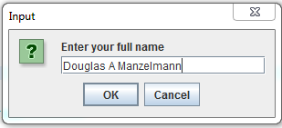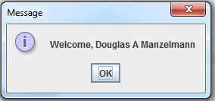

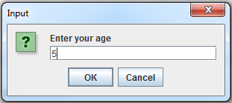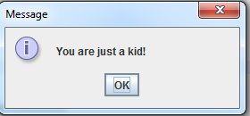

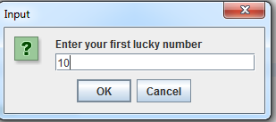

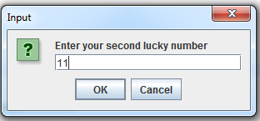

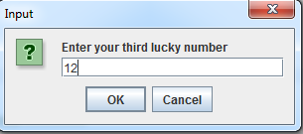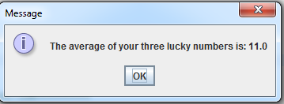

Input Expected Output Actual Output Pass?

|  |  |  |  |
| --- | --- | --- | --- |
| Paul Graham | Welcome, Paul Graham | Welcome, Paul Graham | Yes |
| 48 | Welcome, adult! | Welcome, adult! |
| 10,100,1000 | 370 | 370 |

Input Expected Output Actual Output Pass?

|  |  |  |  |
| --- | --- | --- | --- |
| Rich Hickey | Welcome, Rich Hickey | Welcome, Rich Hickey | Yes |
| 15 | Welcome, teenager! | Welcome, teenager! |
| 2,4,8 | 4.6666666 | 4.6666666 |

Input Expected Output Actual Output Pass?

|  |  |  |  |
| --- | --- | --- | --- |
| Don Knuth | Welcome, Don Knuth | Welcome, Don Knuth | Yes |
| 20 | Welcome, almost-adult! | Welcome, almost-adult! |
| 3, 9, 27 | 13 | 13 |